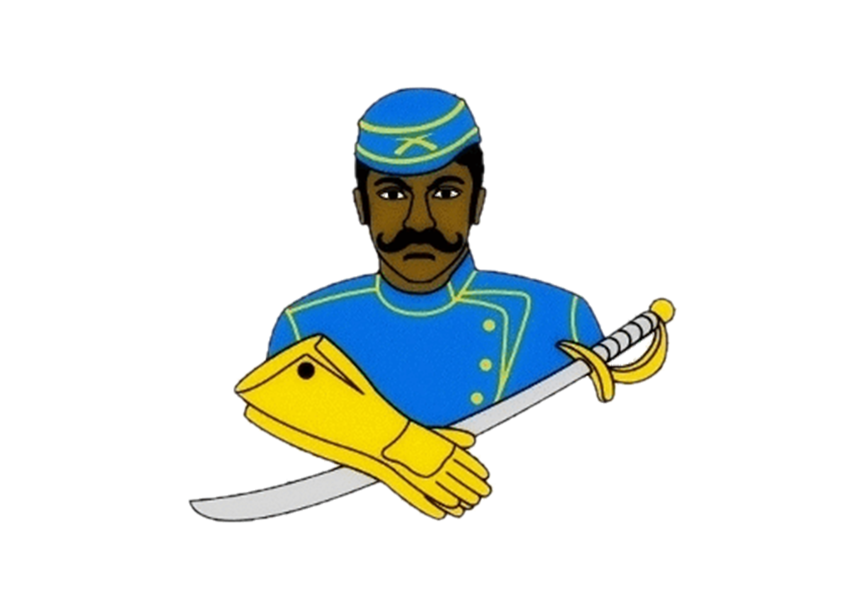
National Association of Buffalo Soldiers & Troopers Motorcycle Club (NABSTMC)
2021 Scholarship Program
http:/www.bsmcflintmi.org

The philosophy of the National Association of Buffalo Soldiers and Troopers Motorcycle Club is:
- To promote the history of African American veterans
- To be a positive role model for youth in our community
- To support our veterans by visiting local veterans, their families, and supporting our fallen heroes
- To support charitable organizations in our community
- To uphold the traditions and standards of the National Association of Buffalo Soldiers and Troopers Motorcycle Club
- To promote motorcycle safety in our community

The National Association of Buffalo Soldiers and Troopers Motorcycle Club (NABSTMC) is comprised of five (5) Frontiers (Northeast, Southeast, Great Lakes, Central, and Western), which encompasses 35 states with an international chapter located in Camp Humphreys South Korea. The NABSTMC has over 113 chapters organizational wide.
There will be 60 recipients across the five frontiers for a total of $50,000.00; and a single National Scholarship of $5,000 will be awarded to one recipient. The NABSTMC will award a grand total of $55,000.00 to college-bound graduating high school seniors in 2021.
The NABSTMC will mail funds, on behalf of the student, upon verification of enrollment to the college/university the student will be attending. Scholarships will be awarded based on a completed application packet, which includes financial need, qualifications, essay, and supporting documentation.
Each frontier winner will participate in an interview and will be vetted by the National Scholarship Committee to determine the National Scholarship Winner.
Instructions for candidates:
The following are required to complete your application:
- Official High School Transcript (or equivalent, if home schooled)
- A 500-word essay on the topics described below in Essay Topics
- Letter of recommendation on official letter head from a teacher/guidance counselor/school administrator
- Letter of recommendation on letterhead from a community service organization
- A letter of acceptance to an institution of higher learning
- Signed Release Form (enclosed)
- Parent’s signature, if student is under 18 years of age
- Prepare a letter of introduction; who you are, your accomplishments, to include honors and awards to date, family background, and the degree to which you are seeking, and financial need. Provide a brief summary on how you plan to use the scholarship, if selected.
- Recent professional headshot photo (in good taste)
- Provide Student’s name, the complete name and address of the school and/or financial aid office where the student will be attending school and student ID number. Checks will be mailed by the National Treasurer to the school via the student’s account
- Complete all forms in its entirety. Attach additional pages, if required.
- Incomplete packages will automatically be eliminated.

Essay Topics:
Write a 500-word essay (typewritten) on one of the following topics:
**Do not write about the Buffalo Soldiers or Troopers Motorcycle Club**
- What impact did the Buffalo Soldiers make in war and/or peacetime? Why is it necessary to pass this legacy on to future generations?

- Provide specific examples of how the Buffalo Soldiers facilitated the development of roadways, national parks, and mail service.

- The Congressional Medal of Honor is presented to the recipient by the President of the United States in the name of Congress. Please provide a brief narrative regarding a Buffalo Soldier that received this honor and what can be learned from his life, efforts, and commitment to duty.

Submit Application:

Applications may be downloaded from www.bsmcflintmi.org. Under the tab scholarship, you will find the application and the email address to return the completed application. Completed applications and required documents must be scanned and emailed to the contact information by May 1, 2021. Subject line is your full name and State. All sealed transcripts must be sent to the mailing address below for your respective Chapter/State (pg. 6) by May 1, 2021. Incomplete packets will be eliminated.

National Association of Buffalo Soldiers & Troopers Motorcycle Club (NABSTMC)
Scholarship Program
2021 Application
Application Deadline: May 1, 2021

Name of local Buffalo Soldier Chapter: _______________________________

Contact Information:
First Name: |  | Last Name:
Address:
City: |  | State:
Zip Code: |  | Email:
Home Phone: |  | Cell Phone:
Date of Birth: |  | Gender:

Academic Information:
High School Name: |  | City / State
Graduation Date: |  | GPA:
Class Rank: |  | Class Size:

College Information (If you have not finalized your college choice, provide your first choice school.):
College Name: |  | City / State:
Institution Type:
Certificate Four-Year Two-Year Vocational or Technical:
Degree Sought: Associates Bachelors Certificate
Major:
Anticipated Graduation Date:

Applicant Service, Extracurricular Activities and Work Experience:

Use this space to provide the applicant’s volunteer service, extracurricular activities and work experience during the applicant’s academic career. Do not attach a resume in lieu of completing this form. It will not be reviewed.

Description
Total Hours or Average Hours per week: |  | Are you still participating? (yes / no)
Start Date: |  | End Date :
Highest Position Held:

Description
Total Hours or Average Hours per week: |  | Are you still participating? (yes / no)
Start Date: |  | End Date :
Highest Position Held:

Description
Total Hours or Average Hours per week: |  | Are you still participating? (yes / no)
Start Date: |  | End Date :
Highest Position Held:

Terms & Conditions:

I, , certify, to the best of my knowledge, that the information on this application is complete and accurate. Falsification of any information will cause my disqualification from the scholarship competition.

(1) It is my responsibility to make sure the application process is complete by the required deadline. If not, the application may be disqualified from the scholarship competition and may not be considered for an award.

(2) This application, upon receipt, becomes the property of the program sponsor.

I agree that, if selected as an award winner for the National Association of Buffalo Soldiers and Troopers Motorcycle Club Scholarship Program, the program sponsor or its agents may use my name and likeness and any other information or materials provided in connection with this program for purposes of news, publicity and advertising in all media, including but not limited to print and electronic media, press releases, internet websites and video media.

To comply with the provisions of the Family Educational and Privacy Act of 1974, I hereby grant permission for school officials to release secondary school records and other requested information, if necessary.

If you are under 18, your parent or guardian must also agree to these Terms and Conditions.

Applicant Signature: Date:

Parent Signature: (if applicable)

** Local Chapter/Frontier must acknowledge receipt before sending to National Scholarship Committee.

Chapter__________________________Signature____________________________________________

National Association of Buffalo Soldiers & Troopers Motorcycle Club
Frontier Scholarship Representatives

Contact | Member | Contact Info
Edward Payne ‘Mbili’ | President | Powertrian1998@gmail.com / (810) 429-0840
Lynn Walker ‘Acacia’ | Secretary | Lynnrwalkermd@gmail.com / (810) 444-3081
BSMC Flint, MI Chapter | Mailing Address | P.O. Box 905 Grand Blanc MI. 48480

