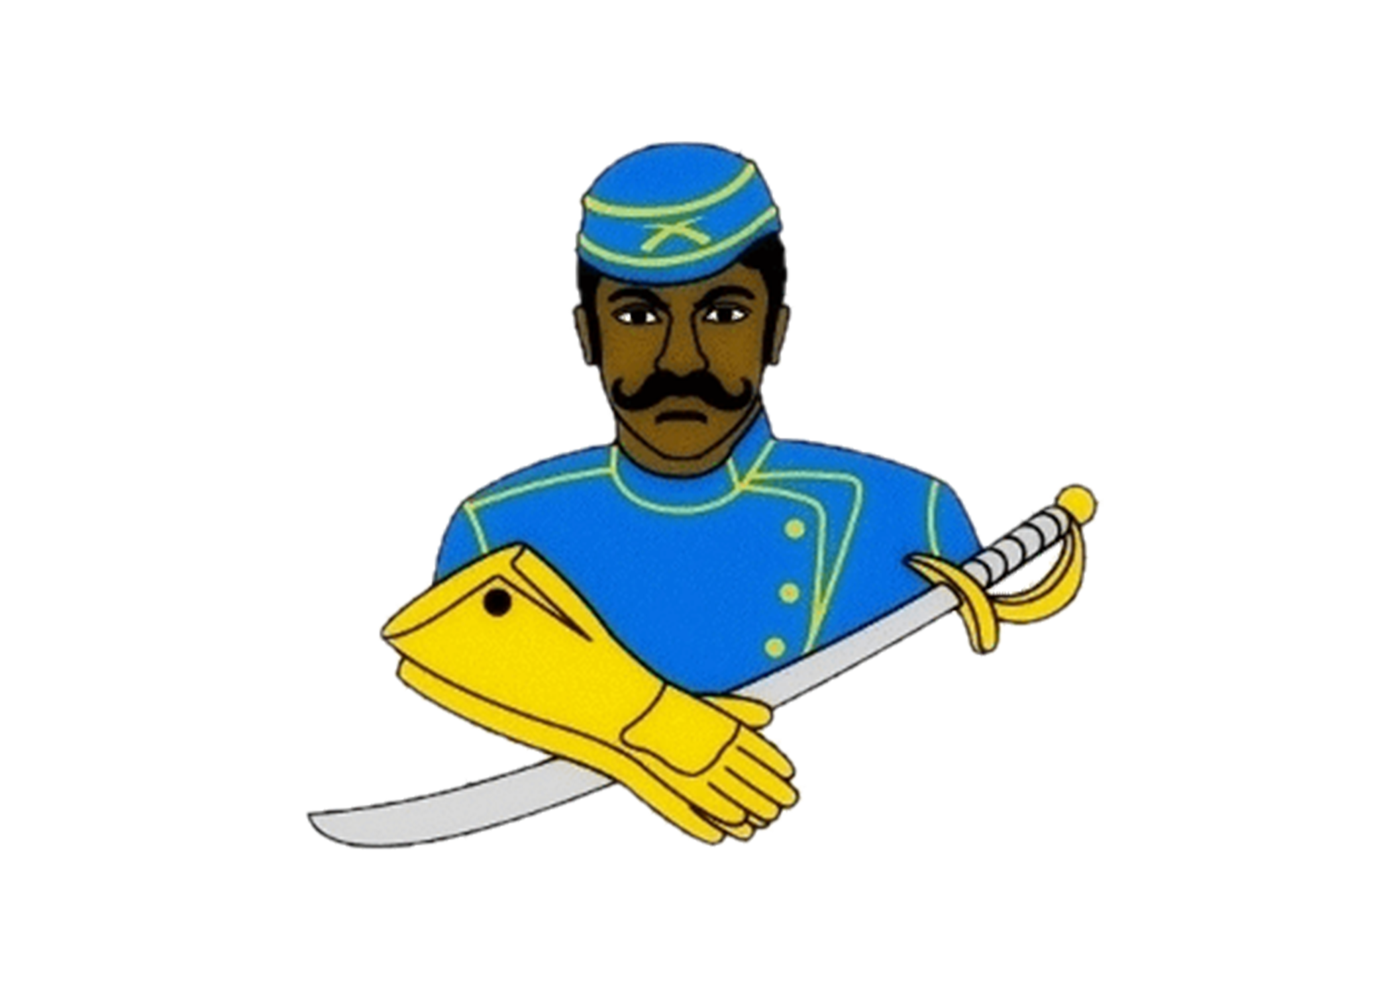
National Association of Buffalo Soldiers & Troopers Motorcycle Club (NABSTMC)
Scholarship Program
2022 Application
Application Deadline: April 1, 2022

Name of local Buffalo Soldier Chapter: _______________________________

Contact Information:
First Name: |  | Last Name:
Address:
City: |  | State:
Zip Code: |  | Email:
Home Phone: |  | Cell Phone:
Date of Birth: |  | Gender:

Academic Information:
High School Name: |  | City / State
Graduation Date: |  | GPA: | GED Score:
Class Rank: |  | Class Size:

College Information (If you have not finalized your college choice, provide your first choice school.):
College Name: |  | City / State:
Institution Type:
Certificate Four-Year Two-Year Vocational or Technical:
Degree Sought: Associates Bachelors Certificate
Major:
Anticipated Graduation Date:

Applicant Service, Extracurricular Activities and Work Experience:

Use this space to provide the applicant’s volunteer service, extracurricular activities and work experience during the applicant’s academic career. Do not attach a resume in lieu of completing this form. It will not be reviewed.

Description
Total Hours or Average Hours per week: |  | Are you still participating? (yes / no)
Start Date: |  | End Date:
Highest Position Held:

Description
Total Hours or Average Hours per week: |  | Are you still participating? (yes / no)
Start Date: |  | End Date:
Highest Position Held:

Description
Total Hours or Average Hours per week: |  | Are you still participating? (yes / no)
Start Date: |  | End Date:
Highest Position Held:

Terms & Conditions:

I, , certify, to the best of my knowledge, that the information on this application is complete and accurate. Falsification of any information will cause my disqualification from the scholarship competition.

(1) It is my responsibility to make sure the application process is complete by the required deadline. If not, the application may be disqualified from the scholarship competition and may not be considered for an award.

(2) This application, upon receipt, becomes the property of the program sponsor.

I agree that, if selected as an award winner for the National Association of Buffalo Soldiers and Troopers Motorcycle Club Scholarship Program, the program sponsor or its agents may use my name and likeness and any other information or materials provided in connection with this program for purposes of news, publicity and advertising in all media, including but not limited to print and electronic media, press releases, internet websites and video media.

To comply with the provisions of the Family Educational and Privacy Act of 1974, I hereby grant permission for school officials to release secondary school records and other requested information, if necessary.

If you are under 18, your parent or guardian must also agree to these Terms and Conditions.

Applicant Signature: Date:

Parent Signature: (if applicable)

** Local Chapter/Frontier must acknowledge receipt before sending to National Scholarship Committee.

Chapter__________________________Signature____________________________________________

